Project on Data Visualization using python.

import pandas as pd

import numpy as np

import matplotlib.pyplot as plt

import seaborn as sns

daily_prices_19 = pd.read_csv("E:\datasets\Daily_Price_19.csv")

daily_prices_15 = pd.read_csv("E:\datasets\Daily_Price_15.csv")

print(daily_prices_19['state'].value_counts())

print("\nThere are totally {} states".format(len(daily_prices_19['state'].value_counts())))

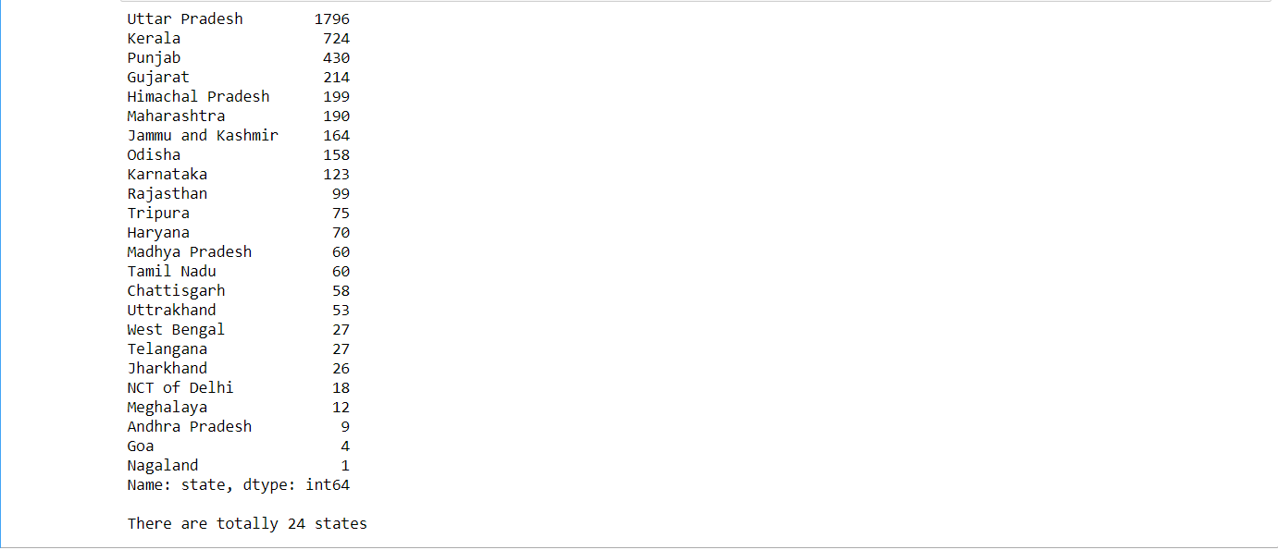

print('The top 3 most frequented comodities at mandies\n')

print(daily_prices_19['commodity'].value_counts()[0:3])

print("\nThere are totally {} commodities that arrivedn15th".format(len(daily_prices_19['commodity'].value_counts())))

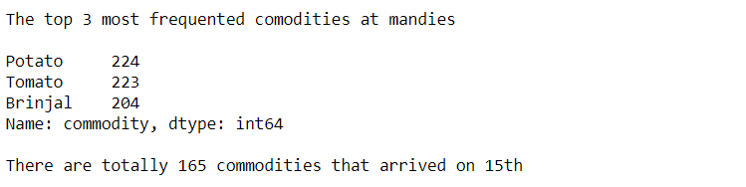

print('The least frequented comodities at mandies on 15th Jan\nThey arrived at only one mandi')

all_commodities = np.array(daily_prices_19['commodity'].value_counts().index.tolist())

mask = daily_prices_19['commodity'].value_counts() == 1

les_freq_commodities = all_commodities[mask]

les_freq_commodities.tolist()

